Pir Mehr Ali Shah

**Arid Agriculture University, Rawalpindi**

*Office of the controller of Examinations*

**Final Exam (Practical) / spring 2021 (Paper Duration 12 hours)**

**To be filled by Teacher**

Course No.: **CS-632** Course Title: **Artificial Intelligence**

Total Marks: **20** Date of Exam: **14-07-2021**

Degree: **BSCS (E)** Semester: **6** Section: **B**

|  |  |  |  |  |  |  |  |  |  |  |  |
| --- | --- | --- | --- | --- | --- | --- | --- | --- | --- | --- | --- |
| **Q. No.** | 1 | 2 | 3 | 4 | 5 | 6 | 7 | 8 | 9 | 10 | Marks  Obtained/  Total Marks |
| **Marks**  **Obtained** |  |  |  |  |  |  |  |  |  |  |  |

|  |
| --- |
| **Total Marks in Words:** |
| **Name of the teacher:** |
| **Who taught the course: Signature of teacher / Examiner:** |

**To be filled by Student**

**Registration No.: 18-ARID-2707 Name: Sayed Yasir Mehdi**

**Answer the following questions.**

**Question No. 1: [10]**

By using neural network algorithm solve the XOR problem. Where X1 and X2 are inputs Y is the output. Learning rate is 0.5. Threshold is 1 if weighted sum >= 0.5 otherwise 0 and weights w1 and w2 = 0.9

Add the last two digit of your Arid number with learning rate and w1, w2 before start solving the question.

|  |  |  |
| --- | --- | --- |
| X1 | X2 | Y |
| 0 | 0 | 0 |
| 0 | 1 | 1 |
| 1 | 0 | 1 |
| 1 | 1 | 0 |

**Ans:**

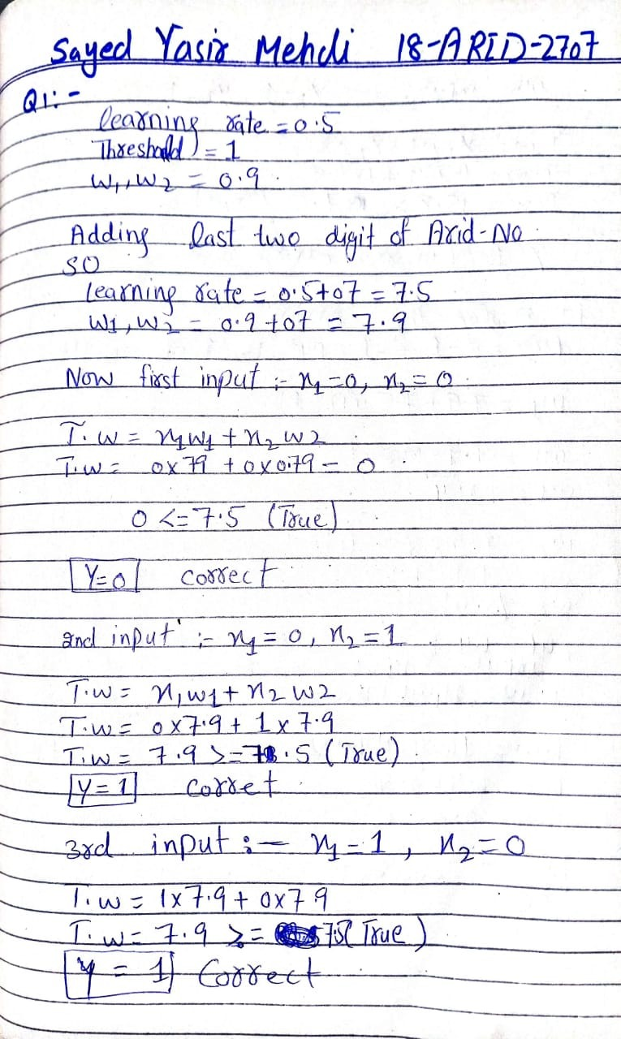

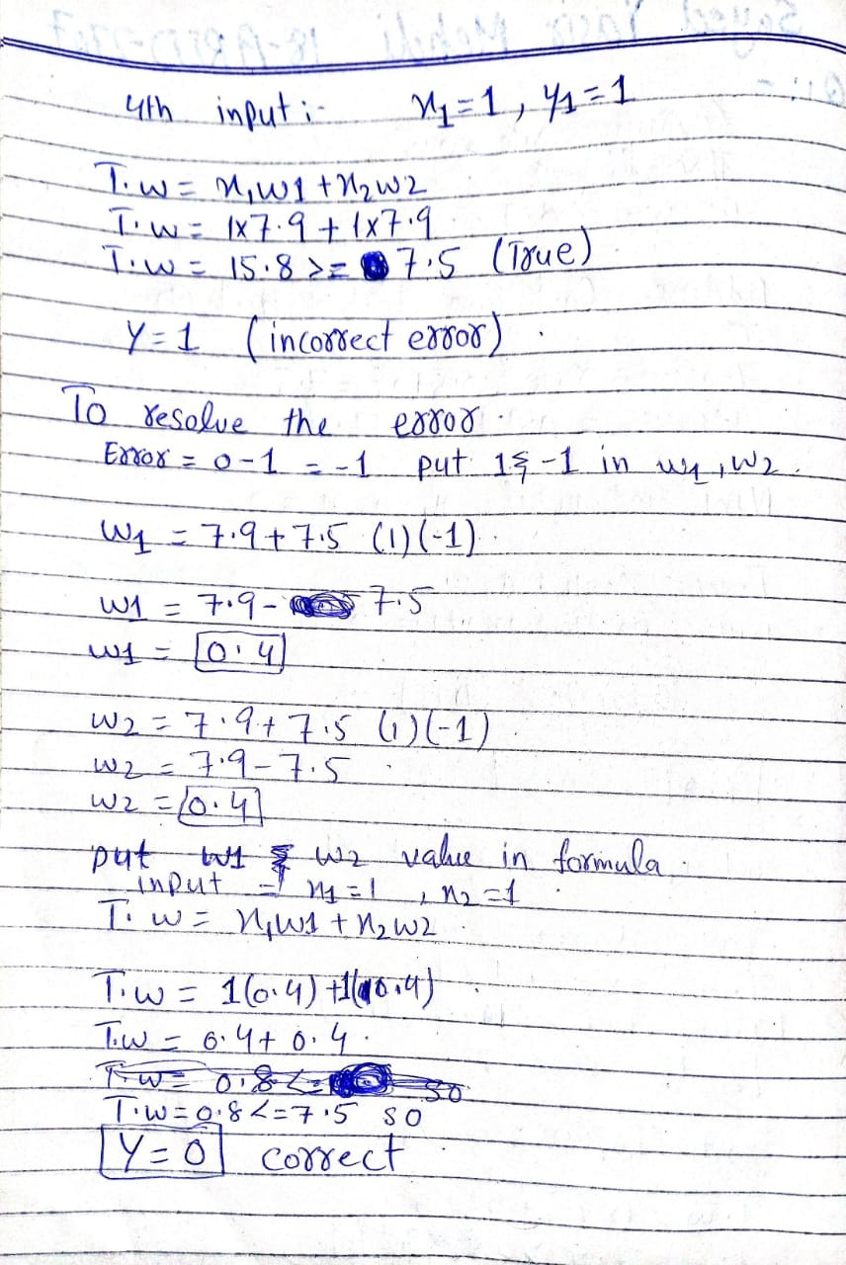

**Question No. 2: [10]**

Write the code to train the neural network using back propagation algorithm for XOR problem?

OR

Briefly describe your semester project**.**

**Ans:**

In my semester project I work from rapid miner to Train the industrial control system dataset .first of all I import the train & test dataset .training dataset is use to construct a model, testing dataset is use to evaluate that model. First of all i apply the decision tree in train dataset so

**Decision Trees** - what are they and why are they useful?

A classic modelling method incorporates the Decision Tree concept as a way to predict future values based on a set of identified attributes, and RapidMiner's straightforward model development user interface makes creating this model about as simple as it can be. The Decision Tree concept is in wide use - for instance it's commonly used by financial institutions when seeking to understand the risks of consumer lending. By examining customer attributes like age and income, and correlating these variables (singly, and in combination) against loan outcomes like defaults, the credit provider can get a sense of the best and riskiest consumers to lend to. Moreover, they can use this information to price their products via their interest rates and other product pricing features. The beauty of the Decision Tree is in its simple-to-understand visualisation of these correlations. If you'd like to understand more about Decision Trees, this article provides a good introduction, however they're generally seen as quite intuitive and you should be able to adequately understand them by following this example.

**Screen shot:**

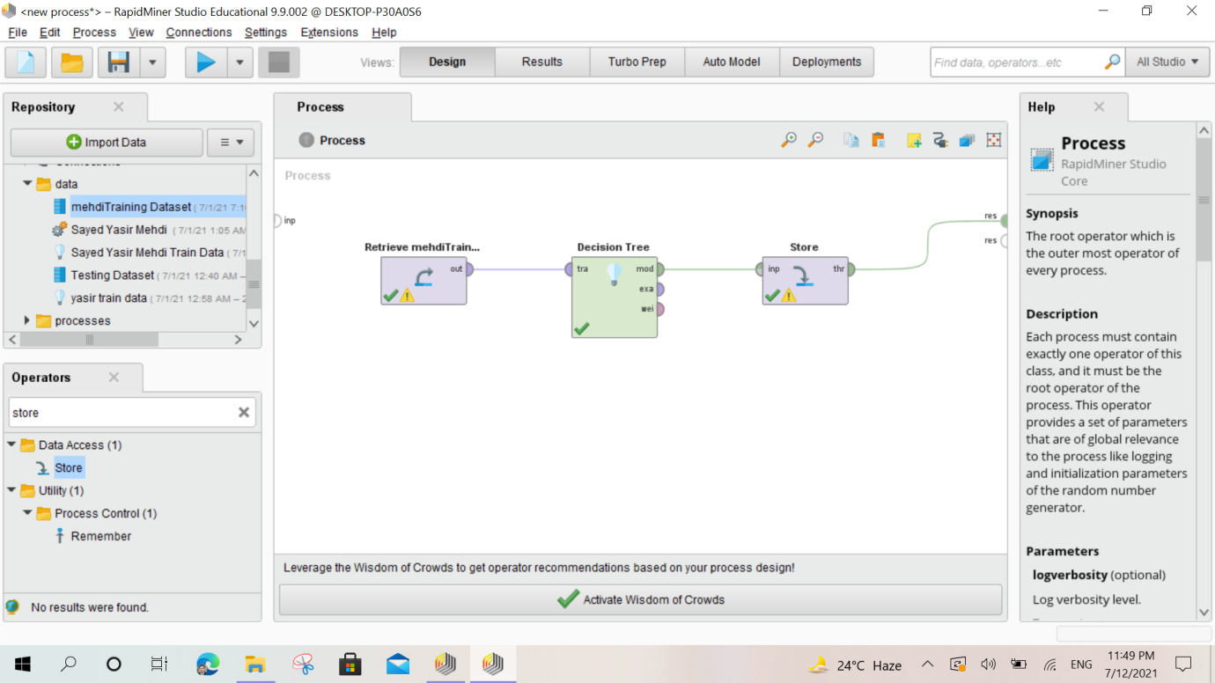

**If we apply decision tree so the result is here :**

**Tree:**

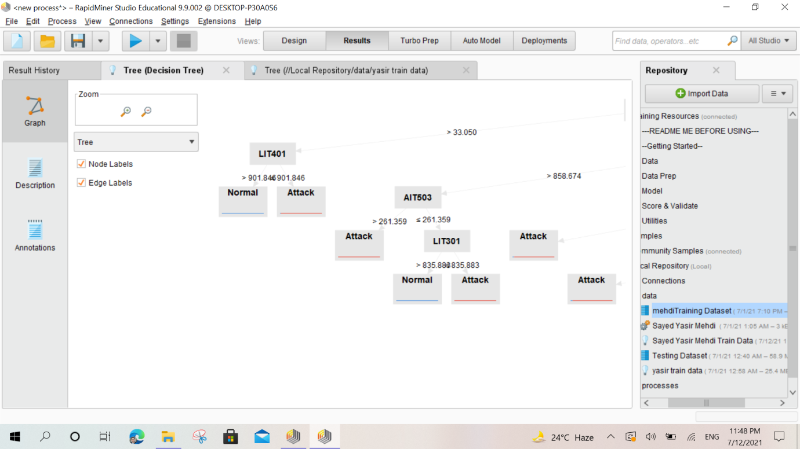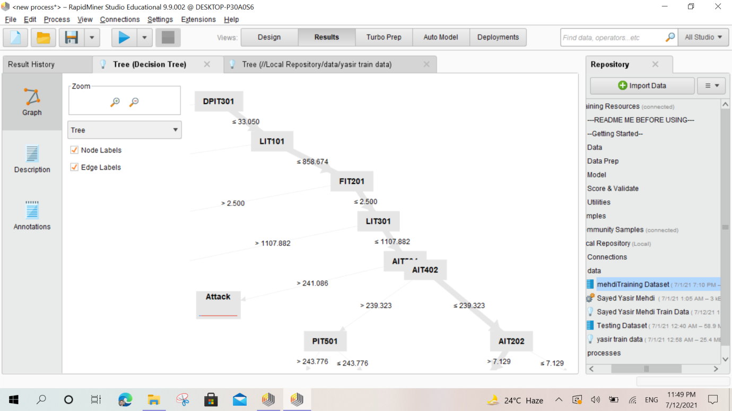

**In the next I am apply model parameter:**

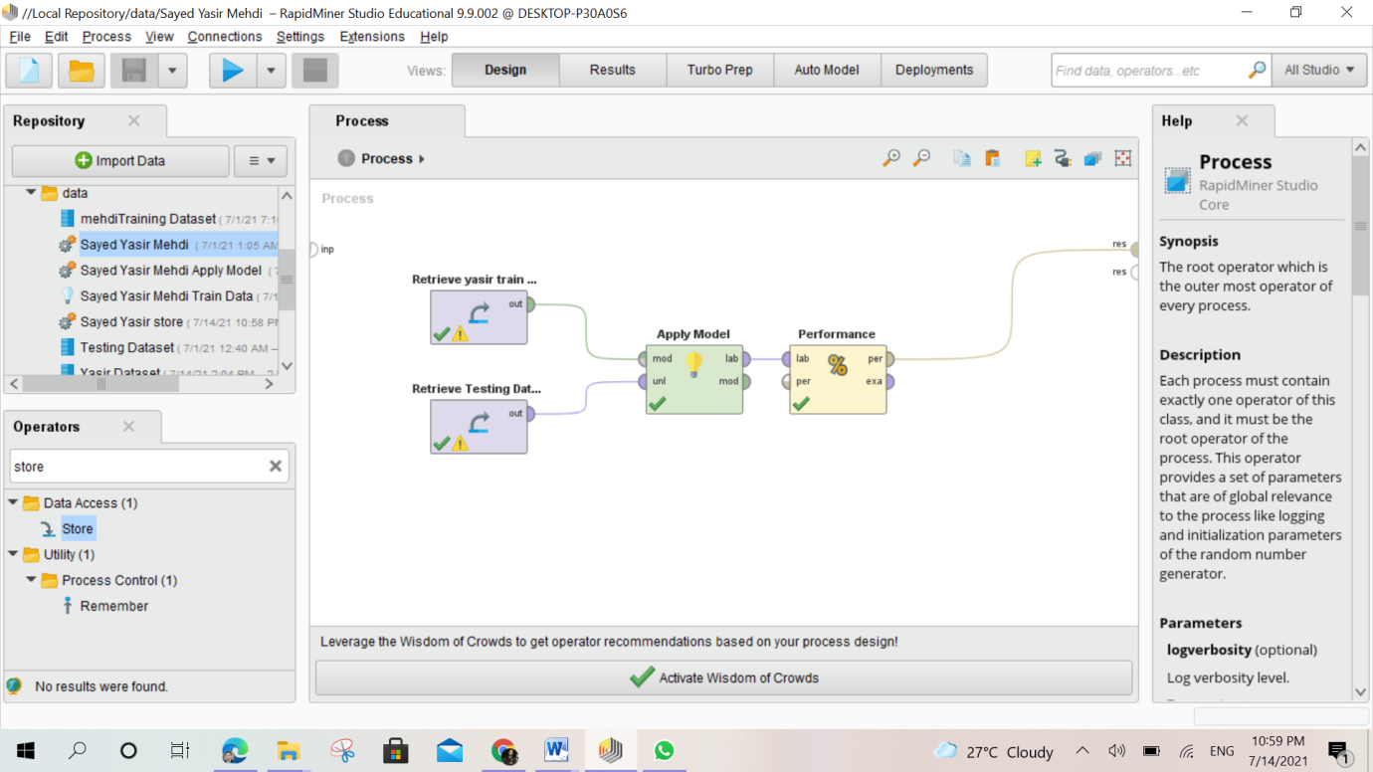

**After Apply model here is the Result:**

**Accuracy:**

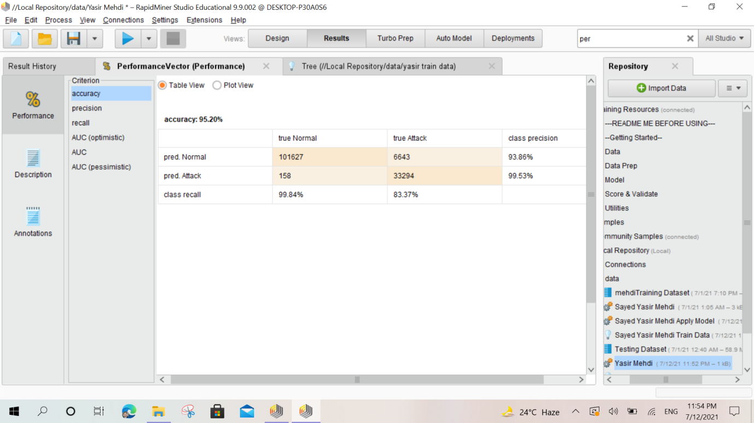

**Precision,**

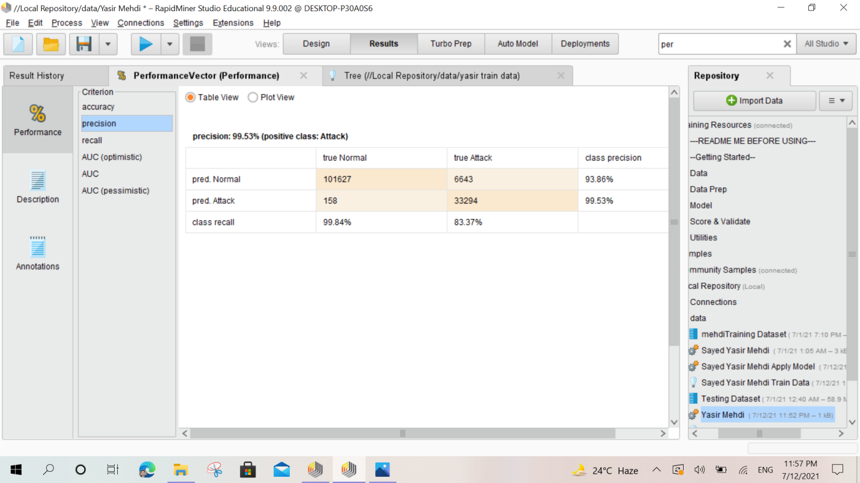

**AUC(OPTIMISTIC)**

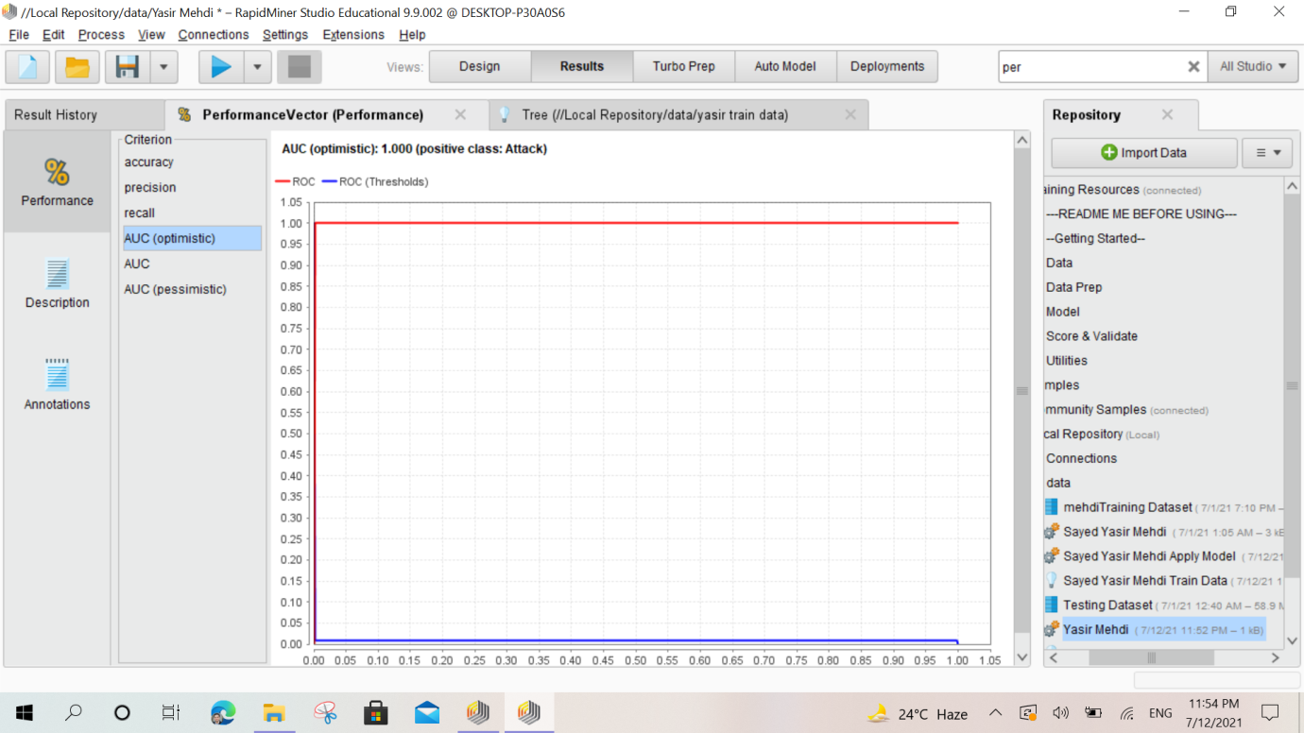

**AUC:**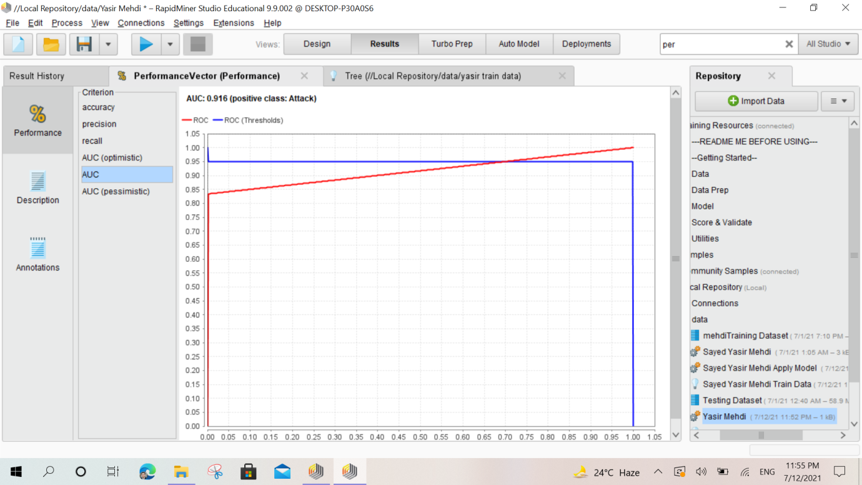

**AUC (PESSIMISTIC)**

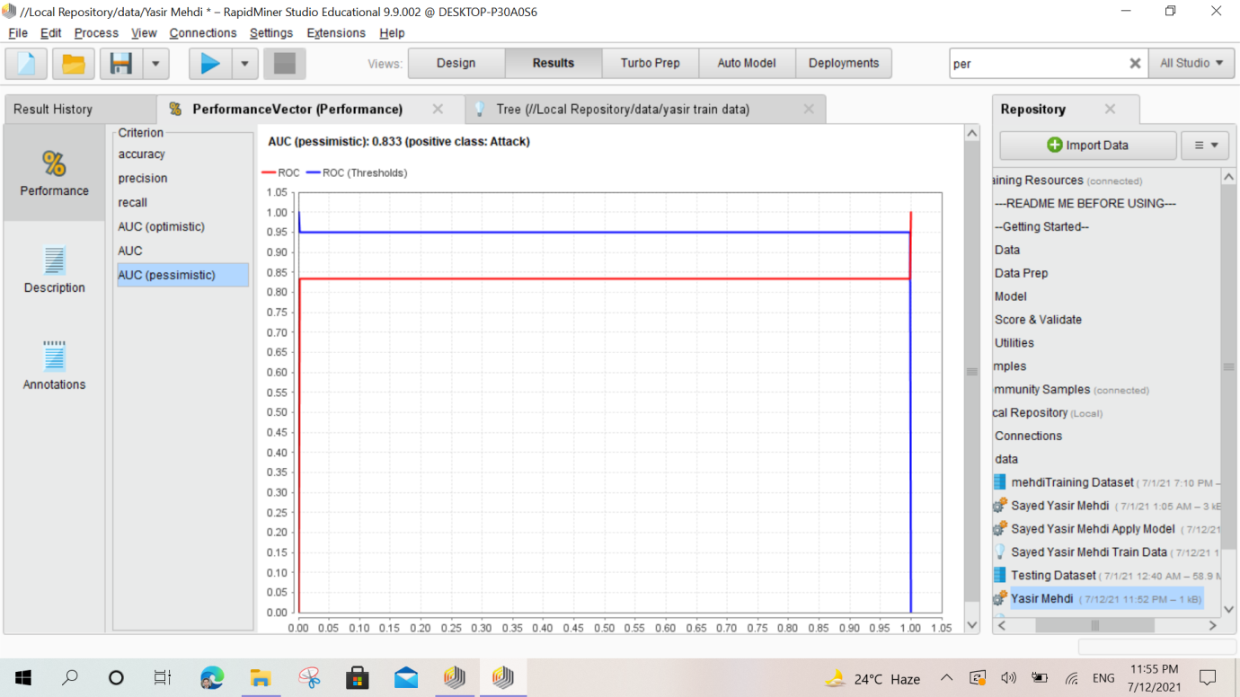

In my presentation day I have 4 presentation before the AI Presentation. So I can not present better but I try 3,4 day to train the data and apply the model .

**Good Luck**